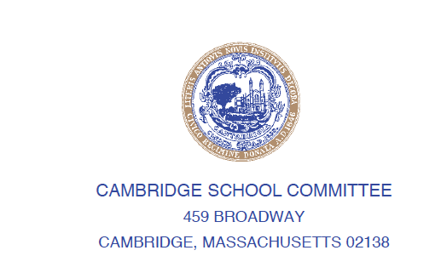

**#25-079**

ELIZABETH HUDSON

325 Harvard Street

Cambridge, MA 02139

ehudson@cpsd.us

RICHARD HARDING, JR.

189 Windsor Street

Cambridge, MA 02139

harding4cambridge@gmail.com

April 1, 2025

WHEREAS: Student-facing positions, including teachers, paraprofessionals, and support staff, are essential to delivering high-quality education and ensuring positive outcomes for all learners; and

WHEREAS: Direct support in the classroom enables teachers to be more effective and responsive, particularly in meeting diverse student needs; and

WHEREAS: Investing in student-facing resources is an investment in immediate educational success, not just long-term planning for potential future success; and

WHEREAS: Meaningful teacher and administrator evaluations are critical tools for professional growth, accountability, and ensuring instructional quality; and allow the district to ensure that every additional dollar invested is spent with purpose and aligned with our educational mission of providing students with critical skills; now therefore be it

RESOLVED: That the Superintendent is directed to add two paraprofessional positions to the District FY26 budget; and be it further

RESOLVED: That the Superintendent is directed to offset the cost of these positions through reductions in areas of the budget that do *not* impact classroom staff or student-facing personnel or critical operations (including transportation and buildings and grounds operations and maintenance); and be it further

RESOLVED: That the Superintendent is directed to ensure full and faithful execution of teacher and administrator evaluations, as outlined in district policy, and to report back on evaluation implementation.